Week 3: Advanced Data Analysis and Visualization in Logistics

1. Exploratory Data Analysis & Visualization Scripts

Visual Analysis 1: Weather Impact on Delivery Speed
Python
import matplotlib.pyplot as plt
import seaborn as sns

plt.figure(figsize=(7, 4))
sns.barplot(x='weather_condition', y='delivery_time_hours', data=df)
plt.title('Average Delivery Time by Weather')
plt.xlabel('Weather Condition')
plt.ylabel('Delivery Time (Hours)')
plt.tight_layout()
plt.show()

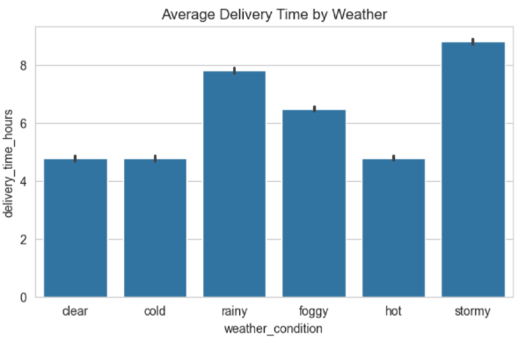

Visual Analysis 2: Partner Cost Efficiency Assessment
Python
plt.figure(figsize=(7, 4))
sns.barplot(x='delivery_partner', y='cost_per_km', data=df)
plt.title('Cost per KM by Partner')
plt.xlabel('Delivery Partner')
plt.ylabel('Cost per KM')
plt.tight_layout()
plt.show()
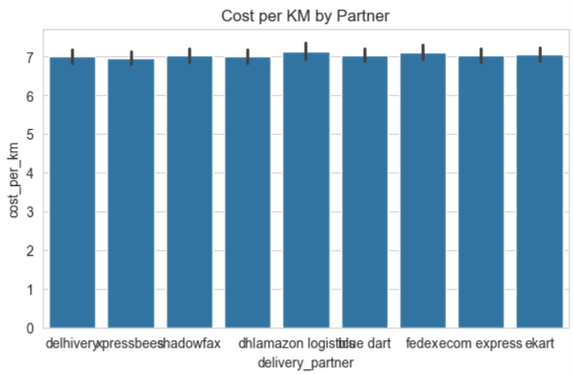

2. Operational Findings & Strategic Insights
Visualization | Observed Insight | Operational Recommendation
Weather vs. Transit Time | Severe weather conditions (storms, heavy rain, fog) substantially increase average transit hours compared to clear conditions. | Dynamically adjust customer ETA delivery windows when adverse weather is forecasted.
Partner vs. Cost Per KM | Distinct price-per-kilometer variations exist across delivery providers, showing cost differences across partners. | Direct cost-sensitive, bulk shipments to lower-cost providers while reserving premium providers for time-critical orders.

